**Ideation Phase**

**Brainstorm & Idea Prioritization**

|  |  |
| --- | --- |
| Date | 27 September 2022 |
| Team ID | PNT2022TMID47172 |
| Project Name | Digital Naturalist - AI Enabled Tool For Biodiversity Researchers |
| Maximum Marks | 4 Marks |

**Brainstorm & Idea Prioritization:**

# Step-1: Team Gathering, Collaboration and Select the Problem Statement

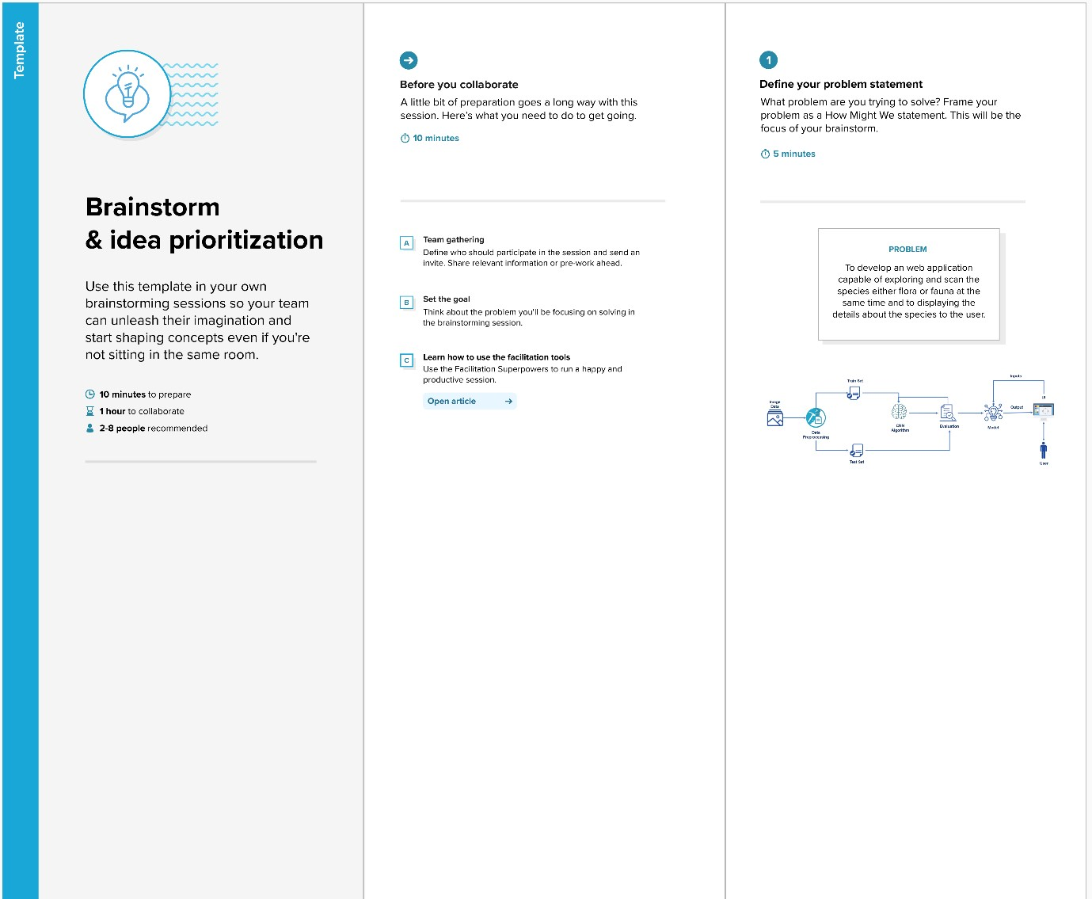

# Step-2: Brainstorm, Idea Listing and Grouping

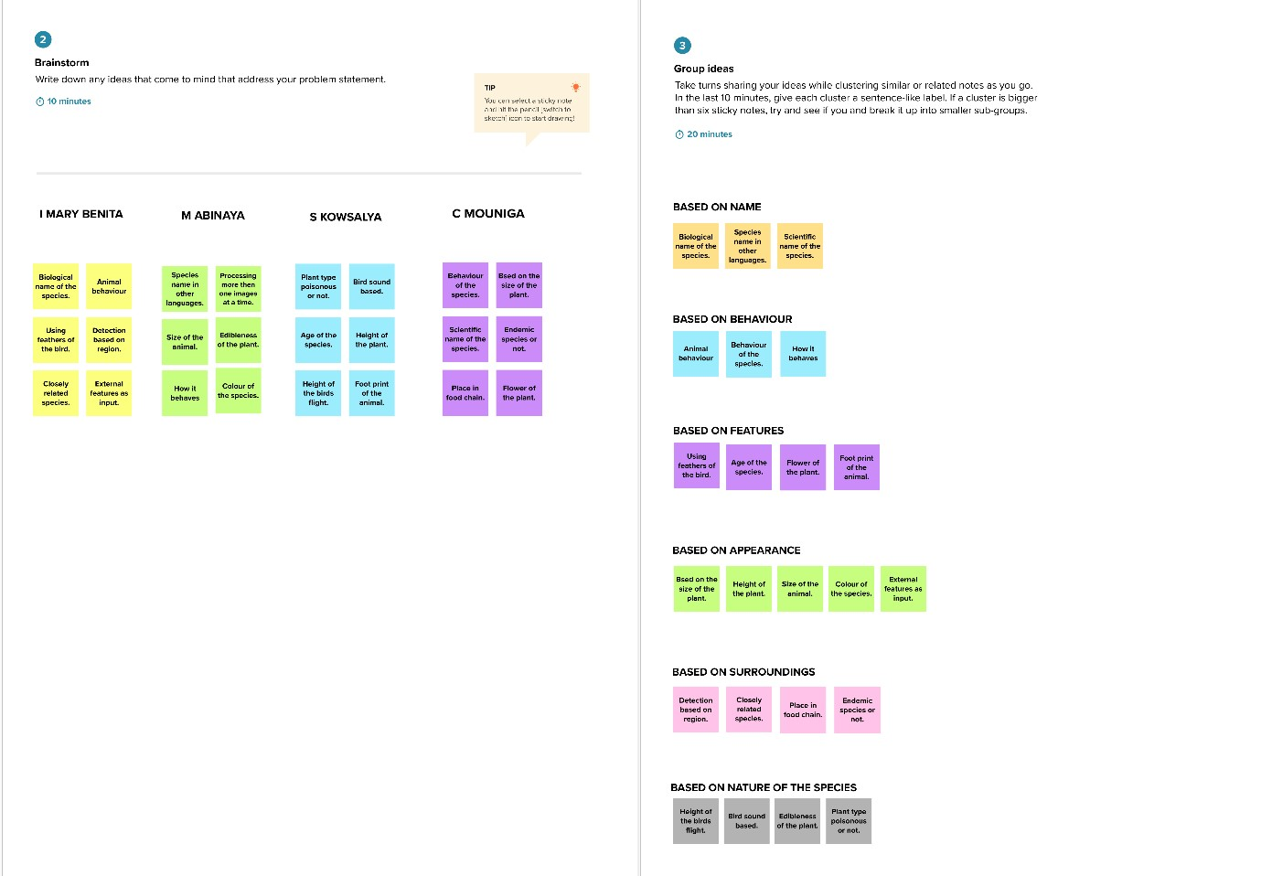

# Step-3: Idea Prioritization

